Big Talking
Primary 7

Term 2
January – March 2020
St. John’s RC Primary School

P7 Big Talking

This booklet contains the Big Talking activities for P7 from January to March. This term we are focusing on imaginative writing and functional writing. On a Tuesday, we will discuss a prompt for their writing which might be an image, question or an animation clip. We have included these in this booklet along with discussion points to help your child prepare for their writing lesson on a Thursday.

These discussion points are designed to be part of a discussion which can be easily worked into your family routine. Your child may wish to make notes of their ideas in their home learning jotter and bring these to class.

Thank you for your continued support,
P7 Teachers

Monday 20th January
Characters
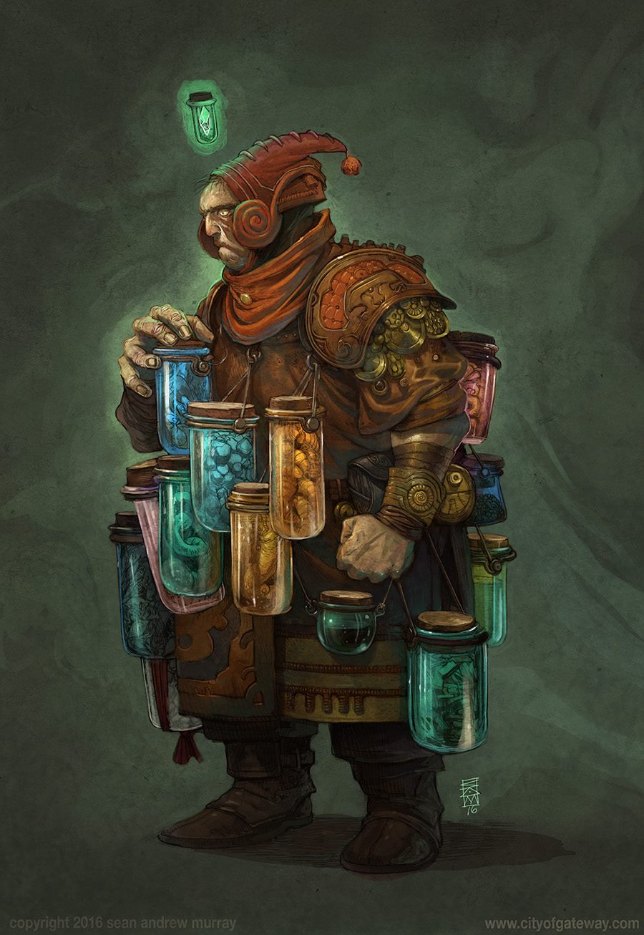
At home discuss:
- Who do you think this is?
- Why is he carrying all of those jars? What’s inside them? Why are they attached to his clothing? Couldn’t he just carry them in a bag?
- Why is he wearing this clothing?
- Is he going to open the blue jar? Why?
- Why is his other fist clenched?
- What does his body language tell you about his thoughts and feelings?
- Choose 3 words to describe this character.

Monday 27th January
Characters
In class, you will be creating a character to develop in your writing. Watch the following clip of ‘Red Miss Take’ from You Tube. In this film the inventor is creating characters for a fairy tale.

https://www.youtube.com/watch?v=aWnKWYYXPOE

Watch the extract at home and discuss:
- Think about the character you would make.
- What would the recipe be for making Harry Potter? Miss Trunchbull (from Matilda)?
- Write the narrative for the story.
- Think about the dialogue between the characters.
- Think about the ending to the story.

Monday 3rd February
Setting

Choose one of the story starters below. In class you will write a five-part story with your chosen story starter as your opening sentence.
- Grey and foreboding, the castle stood atop the hill looking down across the small town, in the topmost window of the highest tower stood a small boy called...

- It was a bright, frosty morning. The pavement glistened like a carpet of crushed diamonds in the early morning sunshine.

- As she walked along the street the tiny dragon in her pocket stirred restlessly.

- It moved, why was it moving? That should not have been moving, well not on its own anyway.

- Everything stopped, people were stood like statues all around me, people in cars, men on bicycles, babies in prams all lifeless, frozen in time.

At home choose a story starter and discuss:
- What has happened leading up to the point in the story starter?
- How could you describe the setting?
- What problem could your character have to overcome?
- How will they do that?
- What has changed by the end of your story?
- How does your story end?

Monday 17th February
Exploring an opinion / viewpoint

In class, you will be exploring your own opinion about the following question:

What is something that should be taught in schools that isn’t?

At home, discuss the following:
- What will we need to know more about in the future?
- What would be helpful for you to know more about?
- What would be the advantages of having these lessons?
- Do other countries/schools teach this?
- What words or phrases could you use to convince someone that your opinion was correct?

Monday 24th February
Exploring an opinion / viewpoint

In class, you will be exploring your own opinion about the following question:

Which would you rather have: money, success or fame?

At home discuss the following:
- What are the benefits of having money?
- What are the disadvantages of having money?
- What are the benefits of having success?
- What are the disadvantages of having success?
- What are the benefits of having fame?
- What are the disadvantages of having fame?
- How could each affect your future?
- For which does the benefits outweigh the disadvantages?
- Is there any evidence from the media that supports your opinion?
- What persuasive language could you use to justify your point of view?

Monday 2nd March
Reporting
In class we will be writing a non-chronological report about the moon, Pandora – the setting of James Cameron’s 2009 movie Avatar.
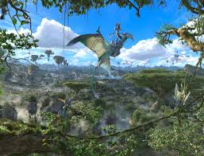
Watch this clip below on Pandora Discovered.
https://www.youtube.com/watch?v=GBGDmin_38E

At home, find out what you can about Pandora.
Think about the following subheadings: location relative to earth, description of Pandora, plant life, animal life, amazing features.
You may have subheadings of your own.
To find out more about Pandora, you may wish to look at:
https://james-camerons-avatar.fandom.com/wiki/Pandora.
Key Vocabulary: Alpha Centauri, Polyphemus, Hexapods, Na’vi, Direhorse, Banshee, Viper Wolf, Hammerhead, Thanator, Bioluminescent, Tree of Souls, Unobtanium.

Monday 9th March
Newspaper
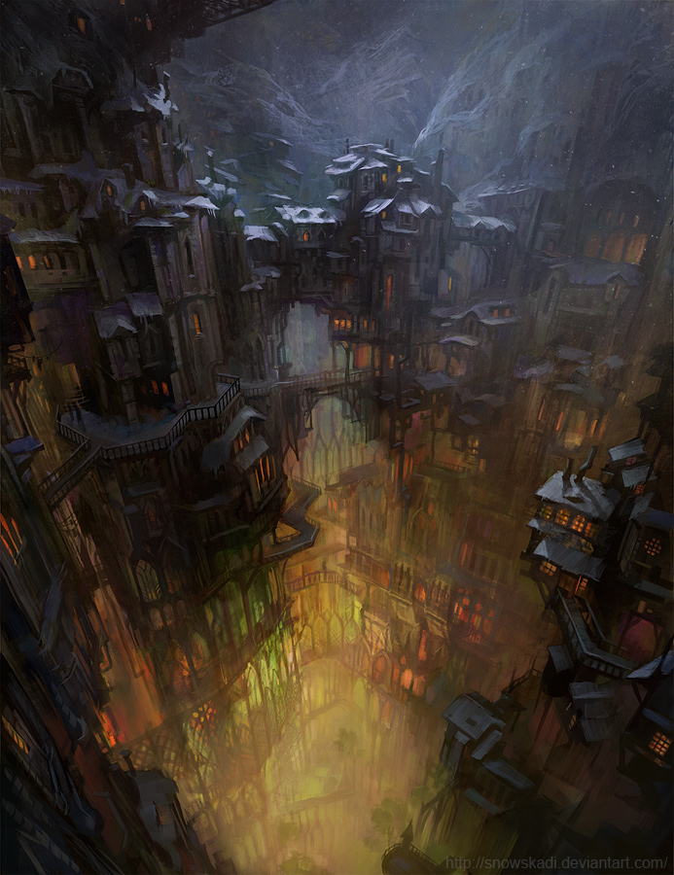

At home, discuss the following:
- Why was this city built in a cave?
- Who built it?
- When was the city founded?
- Who might live here? How large is the population? Are there many children and elderly people here?
- What jobs do the citizens do?
- Is this a good place to live? Is this city well-known for anything? Has anything bad ever happened here?
- Would you like to live here? Why/why not?
- How is this city similar/different to your nearest city?
- Can you think of a headline to match the picture?
Monday 16th March
Reviews
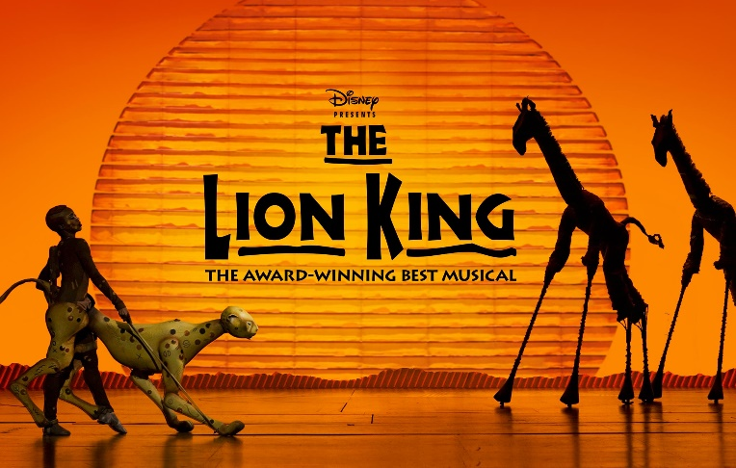
Lion King

Following on from our wonderful whole school trip to see The Lion King at the Edinburgh Playhouse, you will be writing a review of your trip.

At home, discuss the following:
- What made the production special for you?
- How did the scenery and props add to your experience?
- What did you expect to see?
- In what ways was the theatre production different to the film?
- Did this enhance your experience of the production?

Monday 23rd March
Re-draft Week

In class, you will be re-drafting a piece of writing from this term. Think about the feedback you were given and identify how you will improve your first draft.

At home discuss the following:

- Did you use ambitious vocabulary?
- Did you use a range of openers and connectives?
- Have you used punctuation accurately and effectively?
- Is there a clear structure to your story?

