Primary 5 Home Learning
27th February 2023
(All websites given are also on the Home Learning channel on Teams)

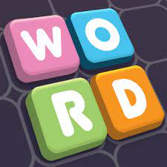
Literacy
Some children have expressed their enjoyment of solving ‘Wordle’. See if they can solve the word each day! https://www.wordlejr.com/
In grammar and writing, we are focusing on using commas to separate items in a list. Give your child 3 or more items and ask them to write a sentence with the items in a list. Remember the last two items should be separated by ‘and’.
Encourage your child to read for at least 15 minutes each day.

Numeracy
In numeracy this week, we are revising division. Complete the Sumdog challenge.
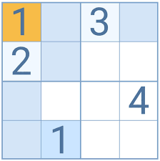
Your child can also complete ‘All Ten’ which they love solving in class! https://beastacademy.com/all-ten
Here is a link to sudoku challenges too: https://www.sudokuonline.io/kids

Health and Wellbeing

On Tuesday and Wednesday when you are not at school, do something that you enjoy! It might be listening to music, painting, going a walk, taking photographs outdoors, baking, playing a musical instrument etc!

