Primary 5 Home Learning
w/c 6th March 2023
Literacy

In literacy, we are talking about childhood toys and train rides, to help build up our knowledge and vocabulary when writing about our story ‘Bike Boy’. Talk to your child about how they show adults they are growing up, and about a time you have been on a train together. What did you see?

Numeracy
In numeracy this week, we are learning about short division. Ask your child to show you the method they are learning this week. Complete the Sumdog challenge.
Your child can also complete ‘All Ten’ which they love solving in class! https://beastacademy.com/all-ten

Social Studies
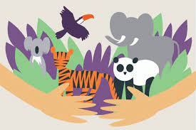
We are beginning our new topic of Endangered Animals this week. Shortly, we will be setting a homework task of giving a presentation about an endangered animal. Start to talk to your child about what animal they might like to present on, and what research they could start doing about this animal.


Music
We have started some rhythmical activities that are designed to help our spelling and how we associate words. With your child, take it in turns to clap the name of a family member. The other person tries to guess the person you are clapping.

