Home Learning - Tuesday 26th of September
Literacy
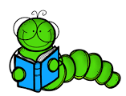
We have some exciting online classrooms for you to visit and explore. Click the clicks below to visit them.
Green: Literacy Classroom ng/nk
Blue: Literacy Classroom Sh, ch & th
Indigo and Violet: Literacy Classroom S
Reading
Practise your speed sounds, green and red words.
Read words/book in your folder and tricky words at back of reading record.
Can you find a story to share and listen to with someone at home?
Practise reading words you recognise in books and the environment.

Writing
In red jotter, practise writing these sounds, words and sentences.
- Green Group: ng, nk sling, ring, trunk, bank The Queen had a ring in the bank.
- Blue Group: sh, th, ch ship, shop, thin, thud, chat, chin The thin ship had a shop.
- Indigo & Violet: m, a, s map, mop, ant, and, sun, sip The ant sat on the map

Numeracy – Counting Backwards
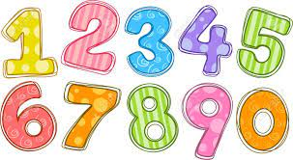
Visit our online P2 Numeracy Classroom Click the link to go explore. P2 Numeracy Classroom

Other activities:
- Practice counting backwards from 20. Count backwards from 30 or 50 to challenge.
- Count forward and backwards within 30 along to this video: Count Forward and back to 30
- Activity – Caterpillar Order and Sequence Game - Choose the sequencing option and choose what number range to play within.
- Activity – Number formation practice
- Practise forming numbers from 1 to 10 in your homework jotter. Make sure they are facing the right way.
Other – African Countries
In school, we have been learning about Africa and its different countries.

- At home, choose an African country to research with an adult’s help.
- Record 3 facts about your African country (draw/write).
- We will share these facts in class.

