Primary 3 Home Learning
Week beginning: Monday 2nd October 2023
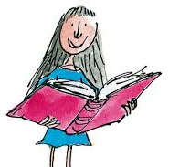
Literacy
Reading
Your child will bring their new reading book home on Tuesday. Ask them to read the speed sounds, green and red words and speed words at the back of the book. Enjoy reading and discussing the story with them.

Phonics

This week we will be consolidating the three sounds your child has learned so far in P3.
They should practise writing words which include these sounds.

Word Wizards – ea, oi and a-e
Friends of Phonics – ee, ay and igh
Super Spellers – sh, ch, th, ff, ss, ll, zz

Here is a padlet which has a variety of games that we use in class! Primary 3 Literacy Padlet
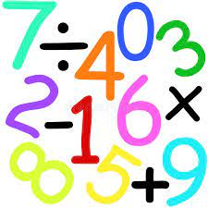
Numeracy
In numeracy, we are adding 10 to a 2 or 3 digit number. Here is the numeracy padlet with games your child can play at home to consolidate their learning. Primary 3 Numeracy Padlet
There is also a Sumdog challenge to complete.

Health and Wellbeing – Zones of Regulation
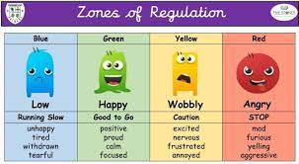
As we have been discussing emotions in class, we have introduced mindfulness activities to have a ‘soft start’ each morning. Try to take 15 minutes each evening to carry out an activity which makes you feel calm and in the ‘green zone’. This might be listening to music, doing a jigsaw, colouring in, painting a picture, reading a book etc.

