Primary 3 Home Learning
Week beginning: Monday 29th April 2024
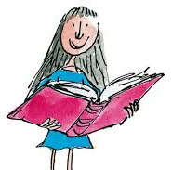
Literacy
Reading
On Tuesday, your child will be given their reading book for the week. Please try to practise this with them at home and discuss the story. Children should also be encouraged to read a book of their choice for enjoyment!

Phonics
We are consolidating our sounds from last week:
Letter Legends – soft c - Letter Legends Padlet
Word Wizards – -cious and -tious words – suspicious, delicious, previous, vicious, ferocious - Word Wizards Padlet
Friends of Phonics – ur sound – nurse, purse, hurt, turn, burn - Friends of Phonics Padlet
Super Spellers – o, oe, oa, ow, o-e sounds - Super Spellers Padlet
Fantastic Phonics – igh sound - high, sigh, thigh, night, fright, sight, light - Fantastic Phonics
Spelling Stars – ‘th’ and ‘sh’ sound - Spelling Stars (padlet.com)
Your child will know which sounds they are learning in class and they should practise the words with that sound in them at home.
Whole class spelling: soft c – cell, exercise, cycle, city, icy, mice, rice, race, face.

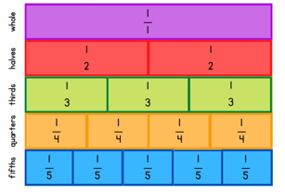
Numeracy – All Ten
We are continuing our work on fractions this week, comparing the sizes of fractions and being able to write them on a number line.
There is a Sumdog competition and the daily challenge called ‘All Ten’.
Primary 3 Numeracy Padlet

Handwriting
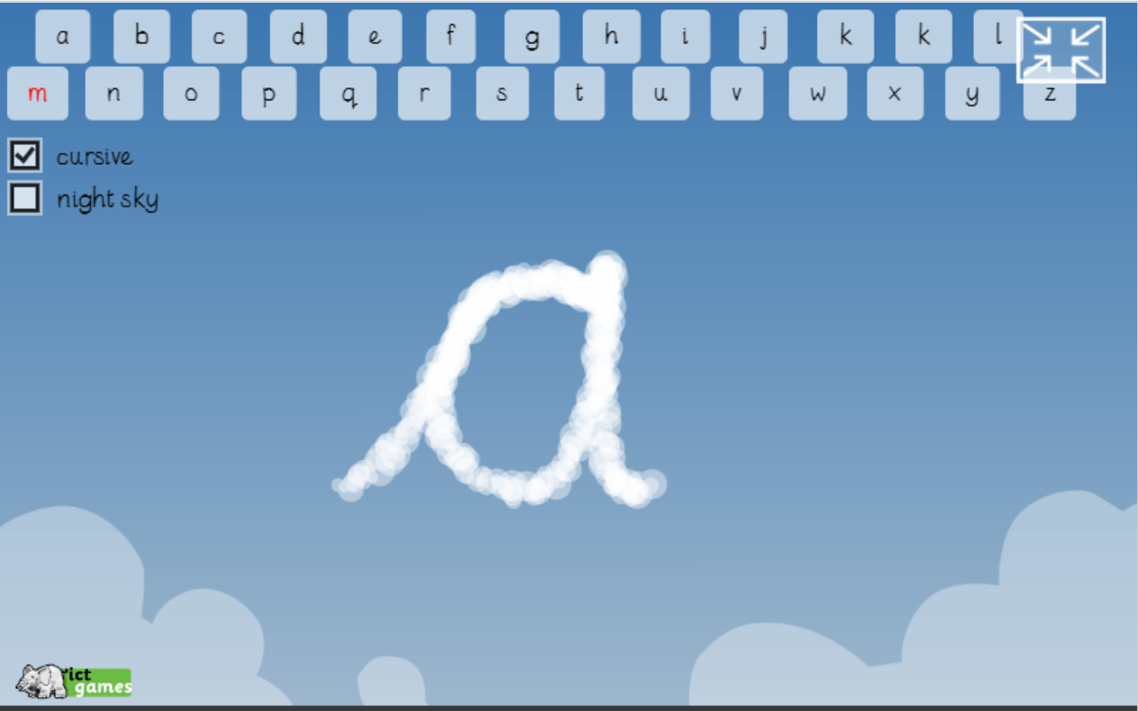
In school, we encourage the children to use cursive handwriting. Below is an example of what each letter looks like in cursive. The website Sky Writer shows the children how they should form each letter.
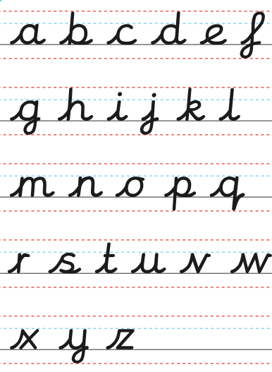

Drama Workshops

This week there will be drama workshops each day with the focus ‘Anti-bullying’. Ask your child to share their learning with you!

