Primary 3 Home Learning
Week beginning: Monday 3rd June 2024
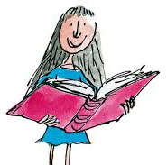
Literacy
Reading
On Tuesday, your child will be given their reading book for the week. Please try to practise this with them at home and discuss the story. Children should also be encouraged to read a book of their choice for enjoyment!
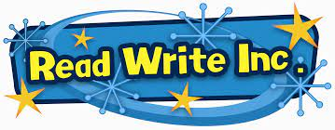
Phonics
We are consolidating our sounds from last week:
Letter Legends – kn and gn words - Letter Legends Padlet
Word Wizards – ue sound – blue, glue, true, clue, rescue, argue - Word Wizards Padlet
Friends of Phonics – oa sound – goat, boat, toast, float, throat, road, coat - Friends of Phonics Padlet
Super Spellers – oo and ew sounds – cook, book, broom, bloom, chew, blew - Super Spellers Padlet
Fantastic Phonics – or sound – sort, short, snort, fork, horse - Fantastic Phonics
Spelling Stars – ‘th’ and ‘sh’ sound - Spelling Stars (padlet.com)
Your child will know which sounds they are learning in class and they should practise the words with that sound in them at home.
Whole class spelling: kn and gn words that make the ‘n’ sound – knit, knock, knot, knee, knew, know, gnome, gnaw.

Numeracy – Money
We have been learning to give change from various amounts. Some have been calculating change from 20p, 50p or £1.
There are games to play on the Padlet and there is a Sumdog challenge to complete.
Primary 3 Numeracy Padlet
IDL – Our Local Area
We will begin learning about our local area this week. In class, we will look at where we are on Google maps. We will look out for key landmarks near our school such as, Figgate Park, Portobello library, Portobello beach, Arthur’s Seat etc. At home, ask your child to show you these landmarks on Google maps.
