Literacy | Numeracy | Topic/Other
Spelling  This week we have a special focus on the following tricky words:  Many, some, should, come, any, would.  Homophones are words which sounds the same but have a different spelling and meaning.  The homophones we will focus on:  their (belonging to someone e.g. that is their bag.)  there (direction e.g. look over there!)  they’re (contraction short for they are)  Your child could write 3 sentences, each including a homophone correctly.  Reading  Please read either your reading book or a book of your choice for 15 minutes every day. | Place Value  This week, we will be counting in 50s. Start by counting in 5s to help them notice the pattern.  0, 5, 10, 15, 20, 25, 30…  0, 50, 100, 150, 200, 250, 300…  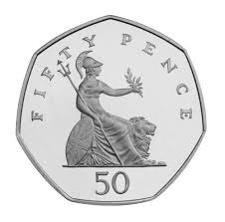  Video: Counting in 50s | Dyslexia Awareness Week  This week is Dyslexia Awareness Week and each child has been given a blue ribbon to wear.  We have discussed what someone with dyslexia might find challenging but also what they can be really good at!  Everyone has different challenges and strengths. Discuss with your child what they find challenging and what helps them. Also discuss their superpowers! What are they good at?  A link for information and games:  Dyslexia Scotland - Unwrapped  