Primary 4 Home Learning – General Information

Literacy
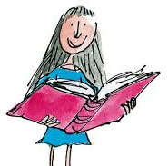
Reading
In class each morning, your child will independently read a book of their choice from the school library. They are also welcome to bring in a book from home.

Your child has been given their new group reading book. Please see their reading record to follow the pages/chapters they should read for the following week. We would appreciate if you could sign the record to show it has been completed. Each group will read with the teacher in class on a Monday, Tuesday, Wednesday or Thursday where we will discuss the pages/chapters. Reading groups are fluid and may change throughout the year!

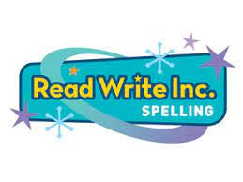
Children who are part of Mrs Crovetti’s group have been informed that we are still awaiting the books to send home but they will be reading in school each day as part of their group work.

Spelling
We will be following the RWI programme. Each week there will be a spelling rule/pattern that we focus on in class. We will share the words that should be practised at home for that week.

Writing
We use the Jane Considine programme: The Write Stuff. We may provide tasks, mostly discussion based, which will help prepare the children with ideas for their writing in class.

Numeracy

We will provide a game and sometimes a video to support and consolidate what we are learning in class that week.
Each week there will be a Sumdog challenge relating to the learning in class.
There is also a daily challenge called ‘All Ten’ which they can complete.

Thank you for your support,
Miss Sinclair and Miss Redman

