Literacy | Numeracy | Topic/Other
Spelling  This week we are focusing on homophones. Homophones are words that sound the same but have different spellings and meanings. Words:  there their  too two  nose knows  eight ate  four for  sea see  Make sure you know the meanings of these homophones. Can you use each pair of homophones in a sentence?  Reading    Please read either your reading book or a book of your choice for 15 minutes every day. | Addition and Subtraction  We are beginning learning on addition and subtraction. To help with the speed of calculations, it is so important that the children can recall number bonds within 10 quickly.  Please practise this with your child using the game below and by testing them.  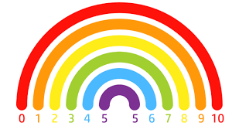  If they are confident with this, they can then practise number bonds within 20 and 100.  Game: Hit the Button  Sumdog challenge | The Blue Planet  We have started our topic on The Blue Planet. Your child has been given an information letter about a presentation task which has to be completed at home over the next few weeks.    Please discuss this with your child and begin by choosing a sea creature they will research and decide how they will present their information to the class, e.g. PowerPoint Presentation, poster, model etc.

