Literacy | Numeracy | Topic/Other
Spelling  This week is a special focus week. We will be learning words that end in -il and words where the ‘s’ makes a ‘zh’ sound.  Some words end in -il. The vowel sound is so short we can hardly hear it. Words:  pencil, evil, fossil, peril, stencil, council, nostril.  Words where the ‘s’ sounds like ‘zh’.  usual, treasure, television, revision, measure.  Practise spelling these words and write 3 sentences with a spelling word in each.  Reading    Please read either your reading book or a book of your choice for 15 minutes every day. | Addition and Subtraction  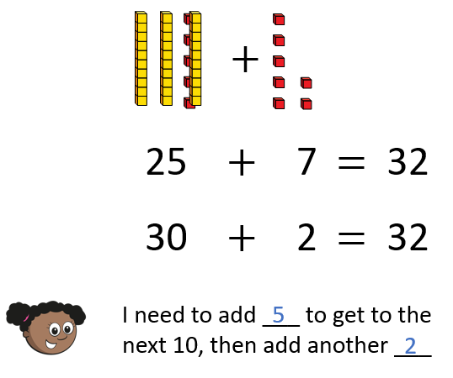  We are learning to adding ones, across a ten.  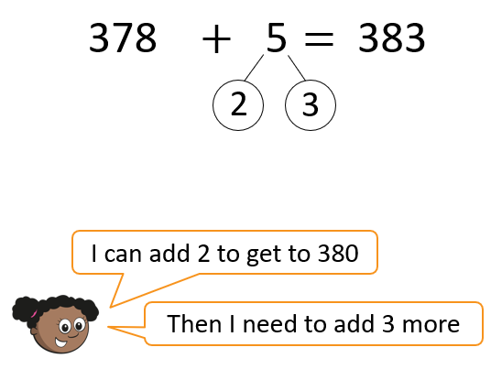  Video link: Adding ones across a ten  Sumdog challenge and Hit the Button game. | The Blue Planet  We will be focusing on plastic pollution this week and how it impacts sea life. Watch the video: Fight Plastic Pollution  The WWF website has lots of information about plastic pollution - do your own research!  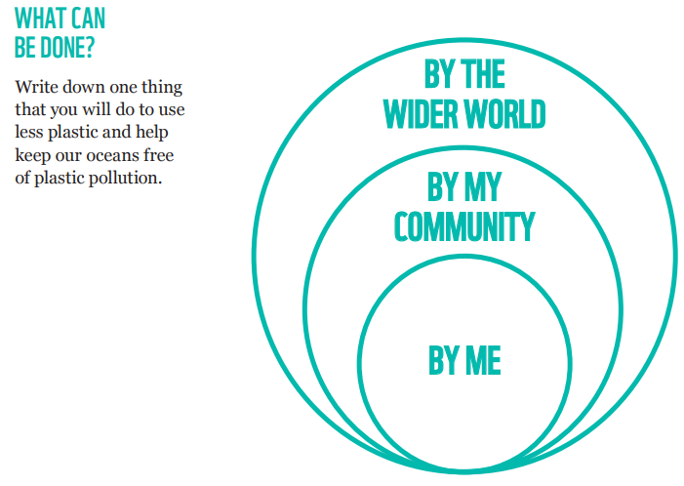  WWF - Plastics

