Literacy | Numeracy | Topic/Other
Spelling  This week we are learning to spell words ending in -el but sounds like ‘l’.  Words:  Camel, tunnel, towel, travel, jewel, label, vowel, tinsel, angel, cancel, level, snorkel.  Practise spelling these words.  Reading  Read the given chapter of your homework reading book for after the holidays.  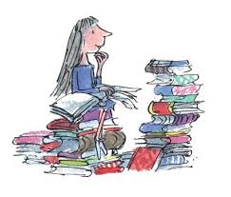  Please read a book of your choice for 15 minutes every day. | Revision  We are learning to use column addition as a written strategy.  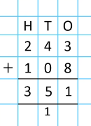  Adding bridging 10: https://vimeo.com/731050814  Adding bridging 100:  https://vimeo.com/731052104  Practise some questions at home. | Online Safety  This week, each class are focusing on the importance of online safety and giving the children tools to use to do this.  Here is a website they can explore at home:  https://www.ceopeducation.co.uk/8_10/stay-safe/  

