Literacy | Numeracy | Topic/Other
Spelling  This week we are learning to spell words with the suffix ‘-less’.  Words:  Painless, fearless, hopeless, pointless, helpless, useless, sleepless, careless, restless, endless, harmless.  Practise spelling these words.  Reading  Read the given chapters of your homework reading book.  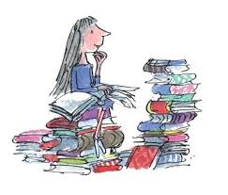  Please read a book of your choice for 15 minutes every day. | Multiplication and Division  We are learning to multiply and divide by 3. Your child should practice counting up in 3s.  3, 6, 9, 12, 15, 18, 21, 24, 27, 30, 33, 36.  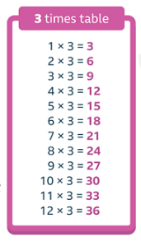  Children should learn the 3 times table off by heart.  They can also practise by playing Hit the Button and there is a Sumdog challenge. | Electricity  How many electrical items can you find in your house? Do they produce heat, light, sound or motion?    Talent Show    There will be a whole school talent show in a few weeks time. In class on Thursday, children who would like to audition for the show will perform their talent to the class. The winners of the auditions will then be in the final!

