Literacy | Numeracy | Topic/Other
Spelling  This week we are continuing to learn to spell words with the suffix ‘-less’.  Words:  Painless, fearless, hopeless, pointless, helpless, useless, sleepless, careless, restless, endless, harmless.  Write 3 sentences. How many of these words can you include?  Reading  Read the given chapters of your homework reading book.  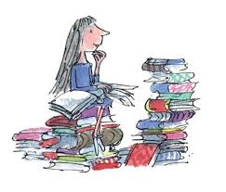  Please read a book of your choice for 15 minutes every day. | Multiplication and Division  We are learning to multiply and divide by 3 and 4. Your child should practice counting up in 3s and 4s.  3, 6, 9, 12, 15, 18, 21, 24, 27, 30, 33, 36.  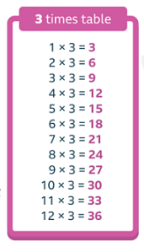  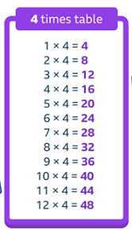  4, 8, 12, 16, 20, 24, 28, 32, 36, 40, 44, 48.  Children should learn the 3 and 4 times tables off by heart.  They can also practise by playing Hit the Button and there are a few Sumdog challenges. | Science - Electricity  This week we will be learning about conductors and insulators.  Here is a website for your child to explore and do their own research:  https://www.switchedonkids.org.uk/  