Literacy | Numeracy | Topic/Other
Spelling  This week we are learning to use contractions. We use an apostrophe.  Words:  I’m, I’ll, I’ve, you’re, you’ve, we’re, we’ve, can’t, don’t, won’t, couldn’t, wouldn’t, shouldn’t.  Games: https://www.spokabulary.com/game?word-list-id=dIkOCmEnrU  Reading  Read the given chapters of your homework reading book.  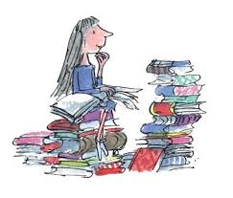  Please read a book of your choice for 15 minutes every day. | Multiplication and Division  We are continuing to multiply and divide by 3 and 4. Your child should practice counting up in 3s and 4s.  3, 6, 9, 12, 15, 18, 21, 24, 27, 30, 33, 36.  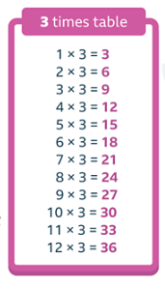  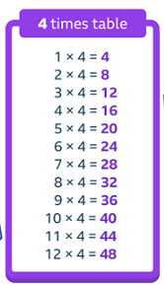  4, 8, 12, 16, 20, 24, 28, 32, 36, 40, 44, 48.  Children should learn the 3 and 4 times tables off by heart.  They can also practise by playing Hit the Button (highest score is 32 so far!) and there are a few Sumdog challenges. | French – Weather  Last week, the children made a fortune teller as a fun way to practise saying the weather in French. Ask them to practise!  Weather Song  Quel temps fait-il? – What is the weather like?  Il pleut – It’s raining  Il fait beau – It’s nice  Il y a du soleil – It’s sunny  Il fait chaud – It’s hot    Il neige – It’s snowing  Il fait froid – It’s cold

