Literacy | Numeracy | Topic/Other
Spelling  This week we are learning to spell words which have the suffix -ment.  Words:  Enjoyment, treatment, punishment, replacement, agreement, payment, basement, movement, measurement.  Games: https://www.spokabulary.com/game?word-list-id=6WVgdNG910  Reading  Read the given chapters of your homework reading book. Please also read a book of your choice for 15 minutes every day.  Epic! (online books)  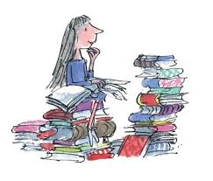  Go to kids.getepic.com/students or click  https://kids.getepic.com/ . You can also download the Epic! app.  P4a class code: iqa6771  P4b class code: ETC1323 | Multiplication and Division  Your child should still continue to practise the 3 and 4 times tables. However, this week we will be learning the 8 times table.  Video: https://vimeo.com/732395579  8, 16, 24, 32, 40, 48, 56, 64, 72, 80, 88, 96.  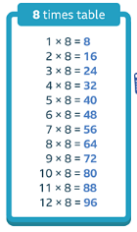  They can also practise by playing Hit the Button and there are a few Sumdog challenges. | French – Weather  Here are some French weather games:  https://wordwall.net/en-gb/community/french/weather/and-activities  