Literacy | Numeracy | Topic/Other
Literacy  Spelling  Spelling Rule: adding im- to words beginning with m or p  Practise spelling the following words:  Reading  Read the given chapters of your homework reading book.    Please also read a book of your choice for 15 minutes every day. | Place Value  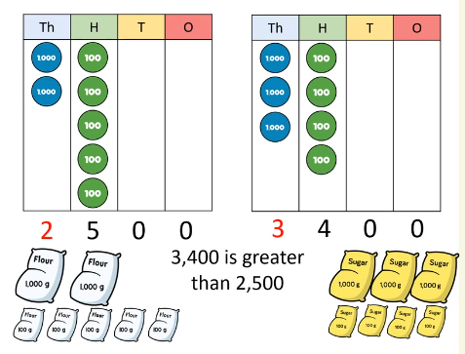  This week, we are learning to compare and order numbers up to 10, 000.  Video links:  Compare numbers - https://vimeo.com/729245522  Order numbers -  https://vimeo.com/729246159  There is a Sumdog challenge to complete. | Handwriting  Letter Join is a new cursive handwriting programme we are using in school.  In primary 5, we will focus on using joined, cursive handwriting.  Login Details  www.letterjoin.co.uk  Press ‘desktop’ or ‘tablet’ at the top of the page depending on the device you are using.    Pupil login: ab25336  Password: Swipe a capital L  Choose class P5a / P5b then ‘Easy Letters’.  They can practise the individual letters and then in the bottom right corner there is ‘practice joins’. Practise diagonal joins.
  Word List
  immortal
  imperfect
  impatient
  impolite
  impossible
  immature

