Literacy | Numeracy | Topic/Other
Literacy  Spelling  LI: We are learning to spell words with silent letters  Practise spelling the following words:  Game: https://www.spokabulary.com/game?word-list-id=rMEtFyYcPF  Reading  Read the given chapters of your homework reading book.  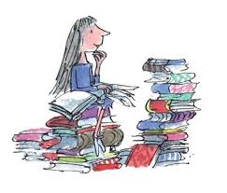  Please also read a book of your choice for 15 minutes every day. | Rounding  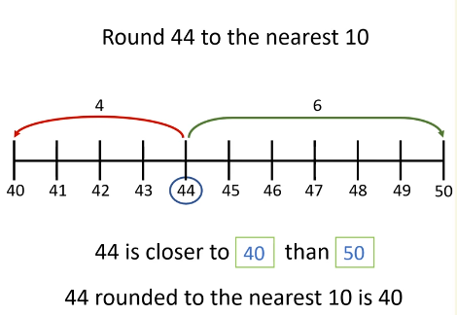  Tomorrow, we will be learning to round numbers up to 10, 000 to the nearest 10.  2358 rounded to the nearest 10 is 2360  Video link: https://vimeo.com/729247885  Game: https://www.topmarks.co.uk/maths-games/rocket-rounding  There is also a Sumdog challenge to complete. | French  We have been learning to have a simple conversation in French.    The children have been learning to greet each other, introduce themselves and ask how someone is.  Have a go at home!  Bonjour! Salut! Bonsoir! Bonne Nuit!  Comment t’appelles tu?  Je m’appelle _________. Et toi?  Je m’appelle ___________. Ca va?  Ca va bien merci, et toi?  Ca va bien merci.  Au revoir!
  Word List
  answer
  island
  February
  length
  strength
  business
  wrong

