Literacy | Numeracy | Topic/Other
Literacy  Spelling  In numeracy, we have been learning to write numbers in words. Practise spelling the following:  The children have also enjoyed solving the daily Wordle challenge – have a go at home! https://www.nytimes.com/games/wordle/index.html  Reading    Read the given chapters of your homework reading book.  Please also read a book of your choice for 15 minutes every day. | Rounding  Tomorrow, we will be learning to round numbers up to 10, 000 to the nearest 100.  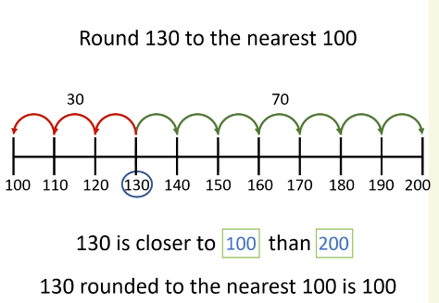  3478 rounded to the nearest 100 is 3500  Video link: https://vimeo.com/729248443  Game: https://www.topmarks.co.uk/maths-games/rocket-rounding  There is also a Sumdog challenge to complete. | IDL – Endangered Animals  We have started our new topic which is on Endangered Animals.  We have discussed what it means when a species is extinct and endangered.  Here is a link for your children to look at so they can familiarise themselves with the animals that are endangered:  https://www.worldwildlife.org/species/directory?direction=desc&sort=extinction_status  Choose an animal that is extinct. Find out the reason for their extinction.  
  eleven | twenty
  twelve | thirty
  thirteen | forty
  fourteen | fifty
  fifteen | sixty
  sixteen | seventy
  seventeen | eighty
  eighteen | ninety
  nineteen | hundred

