Literacy | Numeracy | Topic/Other
Literacy  Spelling  Practise spelling the following words:  Reading  Read the given pages of your homework reading book and sign the reading record.  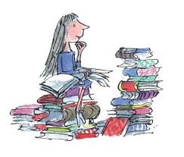  Please also read a book of your choice for 15 minutes every day. | Addition and Subtraction  We have been continuing our work on addition and subtraction.  We have been focusing on ‘compensation’ strategy. This is when you make use of a number that is close to a decade or friendly number (30, 40, 50, 60 etc) to help you with your calculations. For example 19 + 13 could be adjusted to  20 + 12 to make it easier to solve.  Choose some of the sums below to complete for practice. There is also a Sumdog challenge set.  39 + 14  79 + 25  49 + 35  89 + 46  69 + 62 | Carol Singing  As part of our preparation for performing at the Older People’s Project in December, we would like the children to practise their carol singing at home. This will help them feel confident and ready to share their songs with the audience.  Please encourage your child to practise the following songs:  - Rocking Around the Christmas Tree  - It Was on a Starry Night  - Away in a Manger  - Rudolph the red nose reindeer
  Group 1  wander  watch  wasp  wallet  quarrel  quality  quantity | Group 2  beard  near  hear  unclear  appear  dear  year

