Literacy | Numeracy | Topic/Other
Literacy  Spelling  Spelling Rule: the suffix -y  Write each word 3 times in your jotter.  Look at the word, cover it, write it and check it.  Choose 3 words and write a sentence for each word. Try to use describing words to make sentences interesting!  Super Spellers group: Spelling Game  Reading  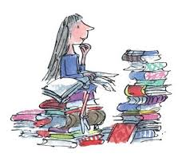  Read the given pages of your homework reading book.  Please also read a book of your choice for 15 minutes every day.  Extra: Choose a task from your reading grid.  Login Details  www.letterjoin.co.uk  Press ‘tablet’ at the top  Pupil login: ab25336  Password: Swipe a capital L starting top left  Choose class P3a / P3b  Choose a section to suit your child. | Time – Calendar Skills  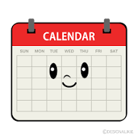  Practise writing the months of the year on a sheet of paper. Cut out the months and order them correctly. Talk about the month before and the month after.  (Remember a capital letter to start)    Play game 1 to practise locating dates on a calendar.   | RE  Please complete Home Session 4 in the Reconciliation Preparation booklet.    OR watch the story of ‘The Lost Sheep’ and discuss the Christian values of love and forgiveness.  https://www.youtube.com/watch?v=smvcsgMv6Dw  Whole School Topic  What makes Scotland, Scotland?    We have been talking about where we come from. If you would like to share a family picture (via email to office) or bring in a photograph, we will show these together and celebrate our diversity.
  Word List
  nutty
  spotty
  boggy
  funny
  sloppy
  sunny

