Literacy | Numeracy | Topic/Other
Literacy  Spelling  Spelling Rule: Tricky words  Write each word 3 times in your jotter.  Look at the word, cover it, write it and check it.  Choose 3 words and write a sentence for each word. Try to use describing words to make sentences interesting!  Super Spellers group: Spelling Game  Reading  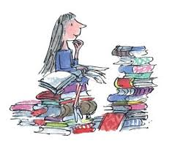  Read the given pages of your homework reading book.  Please also read a book of your choice for 15 minutes every day.  Extra: Choose a task from your reading grid.  Login Details  www.letterjoin.co.uk  Press ‘tablet’ at the top  Pupil login: ab25336  Password: Swipe a capital L starting top left  Choose class P3a / P3b  Choose a section to suit your child. | Time – Telling the Time  Practise o’clock and half past until confident    Challenge: Try quarter past and quarter to      Sumdog  Time Challenge | RE  Please complete Home Session 6 in the Reconciliation Preparation booklet.    https://www.youtube.com/watch?v=cTAxn_GxJ6s Please watch the story of Joseph and his brothers, and discuss the theme of Forgiveness with your child.  Whole School Topic  What makes Scotland, Scotland?    Please see details below of our P1-7 Scots Poetry Competition.  If your child wishes to take part, they can choose one of the P3 poems and practise for the class heats which will be on Monday 9th February.  ‘The Gowk’ and ‘See the Wee Laddie’ are the P3 poems to choose from. We have also sent out a paper copy in bags.
  Word List
  again
  shower
  said
  they
  come
  find

