Literacy | Numeracy | Topic/Other
Literacy  Spelling  Spelling Rule: Tricky Words  Write each word 3 times in your jotter.  Look at the word, cover it, write it and check it.  Choose 3 words and write a sentence for each word. Try to use describing words to make sentences interesting!  Super Spellers group: Spelling Game  Reading  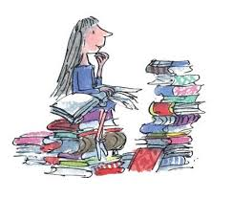  Read the given pages of your homework reading book.  Please also read a book of your choice for 15 minutes every day.  Extra: Choose a task from your reading grid.  Login Details  www.letterjoin.co.uk  Press ‘tablet’ at the top  Pupil login: ab25336  Password: Swipe a capital L starting top left  Choose class P3a / P3b  Choose a section to suit your child. | Multiplication  Please continue to practice on a times table your child would like to work on and record their progress.    Hit the button:  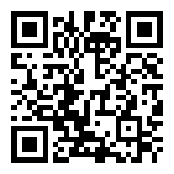  Time Game  Choose level 1, 2 or 3  https://ictgames.com/mobilePage/hickoryDickory/ | RE  Please find the, ‘My Day by Day’ booklet in your child’s bag which has activities related to Lent.    ‘Materials’  Thank you for sending in recycled materials. We will be creating our own art with them this week.  Put some water in your sink and test a collection of items made from different materials to test if they float or sink.  Make a chart and record your findings.
  Word List
  water
  some
  actually
  they
  thought
  again

