Literacy | Numeracy | Topic/Other
Literacy  Spelling  Spelling Rule: The ‘n’ sound spelt ‘kn’ and ‘gn’  Write each word 3 times in your jotter.  Look at the word, cover it, write it and check it.  Choose 3 words and write a sentence for each word. Try to use describing words to make sentences interesting!  Super Spellers group: Spelling Game  Reading  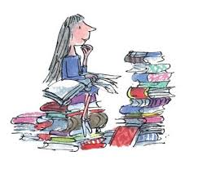  Read the given pages of your homework reading book.  Please also read a book of your choice for 15 minutes every day.  Extra: Choose a task from your reading grid.  Login Details  www.letterjoin.co.uk  Press ‘tablet’ at the top  Pupil login: ab25336  Password: Swipe a capital L starting top left  Choose class P3a / P3b  Choose a section to suit your child. | Multiplication  Please continue to practice on a times table your child would like to work on and record their progress.    Hit the button:      Sumdog  Time Challenge | RE  Please find the, ‘My Day by Day’ booklet in your child’s bag which has activities related to Lent.    Congratulations to the children celebrating their First Reconciliation. Well done on taking this special step in your faith!  ‘Materials’  Hunt for items around the house and sort them into two piles: Waterproof (e.g., metal spoon, plastic toy, glass) and Not Waterproof (e.g., cotton towel, paper, cardboard).  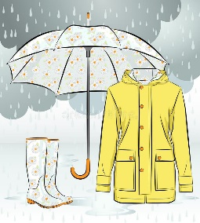
  Word List
  know
  knot
  knight
  gnome
  gnaw
  gnarl

