Literacy | Numeracy | Topic/Other
Literacy  Spelling  Spelling Rule: Tricky words  Write each word 3 times in your jotter.  Look at the word, cover it, write it and check it.  Choose 3 words and write a sentence for each word. Try to use describing words to make sentences interesting!  Super Spellers group: Spelling Game  Reading  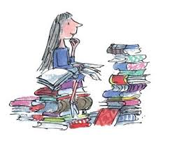  Read the given pages of your homework reading book.  Please also read a book of your choice for 15 minutes every day.  Extra: Choose a task from your reading grid.  Login Details  www.letterjoin.co.uk  Press ‘tablet’ at the top  Pupil login: ab25336  Password: Swipe a capital L starting top left  Choose class P3a / P3b  Choose a section to suit your child. | Fractions  Find fractions of an amount  Fraction Fresco    Multiplication  Please continue to practice on a times table your child would like to work on and record their progress.   | Our Green Planet  Simple Science Experiment  Flower Pressing: Create a simple flower press using heavy books and straps to preserve flowers from a nature walk, allowing for further study.  
  Word List
  their
  there
  know
  through
  exciting
  some

