Literacy | Numeracy | Topic/Other
Literacy  Spelling  LI: We are learning to spell List 9: School & Learning Words  - exercise  - library  - paragraph  - sentence  - dictionary  - knowledge  - question  - answer  - subject  - project  Reading  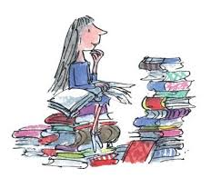  Read the given chapters of your homework reading book.  Please also read a book of your choice for 15 minutes every day. | Timetables practice -  IMPORTANT  https://www.topmarks.co.uk/maths-games/hit-the-button  Decimal and money activities tailored to our exact learning in class on sumdog.  decimal place value video explaining decimal placement.  Extra Game to reinforce learning (both for decimals and money.  https://www.teacherled.com/iresources/decimals/comparedecimals/  https://www.topmarks.co.uk/money/toy-shop-money | Money topic:  Let your child take charge of planning a family meal or a picnic. Give them a strict budget and look at supermarket catalogs or online grocery apps to see if they can buy all the ingredients without going over their allocated amount.  __________________________________  Outdoor learning -Gardening  Fairy Gardens: Use a small patch of dirt or an old planter to build a magical miniature landscape using sticks, moss, and tiny potted ferns

